Network requirement analysis and plan

Student ID : MIT232995

Student Name : Thushar Thymagondlu Anjanappa

Unit Code : MN625

Unit Title : Software Managed Network

Table of Contents

1. Project Scope and Report Requirements 5

Business Case Study: Memorial Regional Healthcare Network 5

Information Utilization Table: 5

Conflicting Requirements and Solutions: 6

2. Network Design and Justification 6

Network Architecture: 6

Justification of Architecture Choice: 6

Configuration on Network Devices and Network Diagram: 7

Configuration of routers: 7

Configuration of Switch: 11

Routers Interface and IP route brief: 21

Cisco Packet tracker Schematic Diagram: 24

IP Addressing Scheme: 24

*IP Addressing Scheme (MIT ID: 232995)* 24

DHCP Allocation Configuration Table 25

VLAN Assignment Table 26

Result: Ping Connectivity 26

DHCP allocation of IP address to PCs: 28

Summary: 30

References: 30

Table of Figures

Figure 1:Configuration for Router 1 with DHCP and Encapsulation 8

Figure 2 Configuration for Router 2 with DHCP and Encapsulation 9

Figure 3 Configuration for Router 3 with DHCP and Encapsulation 11

Figure 4 Configuration for Small switch 1 to trunk between Router and other switches 12

Figure 5 Configuration for Small switch 2 to trunk between Router and other switches 13

Figure 6 Configuration for main switch1 [Admin] between Trunk small switch 1 and PCs 15

Figure 7 Configuration for main switch2 [Clinical] between Trunk small switch 1 and PCs 17

Figure 8 Configuration for main switch3 [Records] between Trunk small switch 2 and PCs 19

Figure 9 Configuration for main switch4 [Guest] between Trunk small switch 2 and PCs 21

Figure 10 IP configure status and IP routing of Router 1 22

Figure 11 IP configure status and IP routing of Router 2 23

Figure 12 IP configure status and IP routing of Router 3 24

Figure 13 Implementation of Healthcare Network Architecture on Cisco Packet tracker 25

Figure 14 Ping connectivity between PCs with single VLAN 27

Figure 15 Ping connectivity between PCs with Different VLAN 28

Figure 16 Ping connectivity between Router and PC of admin department 28

Figure 17 DHCP allocation of IP address on VLAN 10 29

Figure 18 DHCP allocation of IP address on VLAN 20 29

Figure 19 DHCP allocation of IP address on VLAN 30 30

Figure 20 DHCP allocation of IP address on VLAN 40 30

List of Tables

Table 1 Information Utilization table for Network Design 5

IP Addressing Scheme (MIT ID: 232995) Table 2 Shows various device used in the network Design and Configuration associated 24

Table 3 Show various DHCP Pool allocation on the VLAN and their IP range 25

Table 4 Shows Assignning VLAN to different department 26

# 1. Project Scope and Report Requirements

## Business Case Study: Memorial Regional Healthcare Network

**As Memorial Regional Healthcare expands their digital infrastructure the healthcare organization prepares its networks to support both a new electronic health record (EHR) system and expanding telehealth services [1]. The organization maintains a central main hospital facility together with an administrative building and three satellite clinics. The present network operation encounters peak hour slowdowns and security risks between departments while facing poor resource management [3]. The IT team marked these problems as fundamental obstacles which prevent quality patient care delivery.**  
Objectives:

1. **The hospital should establish encrypted paths for information transfer among clinical departments and administrative offices [2].**
2. **A method of segmenting network traffic through VLANs will increase security measures for critical patient data [2].**
3. **Dynamic IP addressing serves as a solution to handle the increasing medical and IoT device numbers [4].**
4. **The organization requires us to design an economical network infrastructure for future expansion of new facilities [6].**
5. **The organization should adopt security protocols that fulfill healthcare privacy rules [3].**

## Information Utilization Table:

Table Information Utilization table for Network Design

|  |  |
| --- | --- |
| **Information Source** | **Relevance to Network Design** |
| **Research with staff members** | **Showed that departments needed to be split into segments with different access priorities.** |
| **Analysis of facility floor plans.** | **Helps Network equipment placement within the building space** |
| **The network audit** | **Identified more than 200 devices that need access to the network.** |
| **Security compliance report** | **Showed existing security vulnerabilities along with their critical remedial actions.** |
| **Budget documents** | **Equipment selection for the project had to meet budget** |

## 

## Conflicting Requirements and Solutions:

1. **Security problems develop because medical devices need direct connections thus organizations establish controlled medical device VLANs with proper access controls and monitoring.**
2. **The organization should use practical cost-effective redundant system deployment to critical systems followed by basic network implementations in non-critical areas.**
3. **User convenience vs. security protocols, to implement single sign-on with multi-factor authentication for clinical workstations**

# 2. Network Design and Justification

## Network Architecture:

My network design consists of three hierarchical tiers that have been modified based on references in literature [6].

1. Maximum uptime availability stems from three enterprise-grade routers organized in redundant triangle distribution [1].
2. Traffic filtering along with inter-VLAN routing happens through four managed switches within this layer [2].
3. End-user devices, medical equipment as well as IoT systems connect to Edge switches at this level of the network [4].

### Justification of Architecture Choice:

#### Medical networks need to fulfill below requirements in healthcare facilities:

1. Patient care systems need continuous 24/7 uptime because “**high availability**” stands as a key requirement. No critical services experience disruption because the triangular core router design implements redundancy [1].
2. The network distributes information security limits across departments which process different levels of sensitive material. The distribution level enables “**VLAN segregation and security”** policy application [2].
3. An architectural flexibility present in this design enables organizations to increase capacity through new satellite clinic construction or expansion by adding hospital wings without reconceiving their entire network structure through “**Scalability”** [6].
4. Medical imaging as well as telehealth operations must have access to abundant high bandwidth capabilities. Traffic aggregation through the hierarchical design helps achieve “**maximum efficiency**” and prevents bottlenecks according to [4].

#### The healthcare environment demands a network design that provides:

* **High Availability:** Patient care systems require 24/7 uptime. The triangular core router design provides redundancy so no single failure can disrupt critical services [1].
* **Security Segmentation:** Different departments handle varying levels of sensitive information. The distribution layer allows for VLAN segmentation and security policy enforcement [2].
* **Scalability:** The modular nature of this design allows for adding new wings or satellite clinics without redesigning the entire network [6].
* **Performance:** Medical imaging and telehealth services require high bandwidth. The hierarchical design prevents bottlenecks by aggregating traffic efficiently [4].

The DHCP server controls and assigns all addresses between 172.16.10.11 to 172.16.10.255 and specifically allocates addresses 172.16.10.1 to 10 exclusively to critical infrastructure devices [4]. The network falls under a dual implementation structure of traditional IP classes and CIDR principles to guarantee efficient management and network expansion [5].

## Configuration on Network Devices and Network Diagram:

### Configuration of routers:

1. Router 1

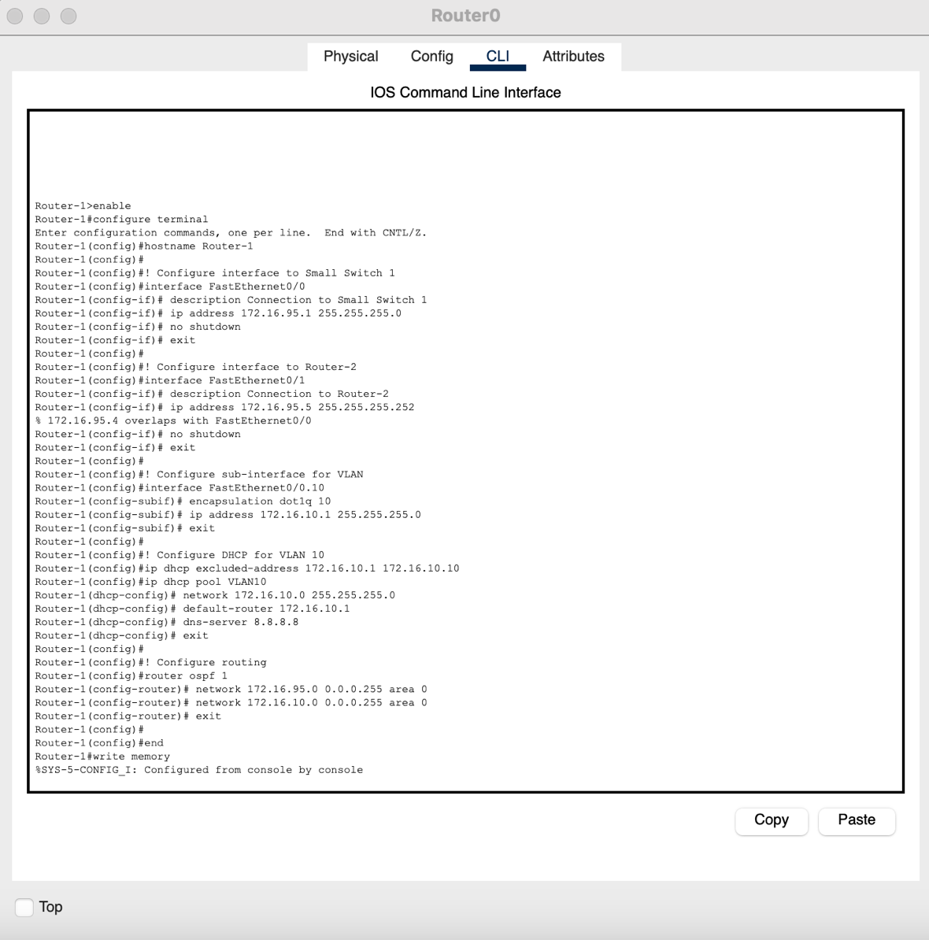

Figure 1:Configuration for Router 1 with DHCP and Encapsulation

1. Router 2

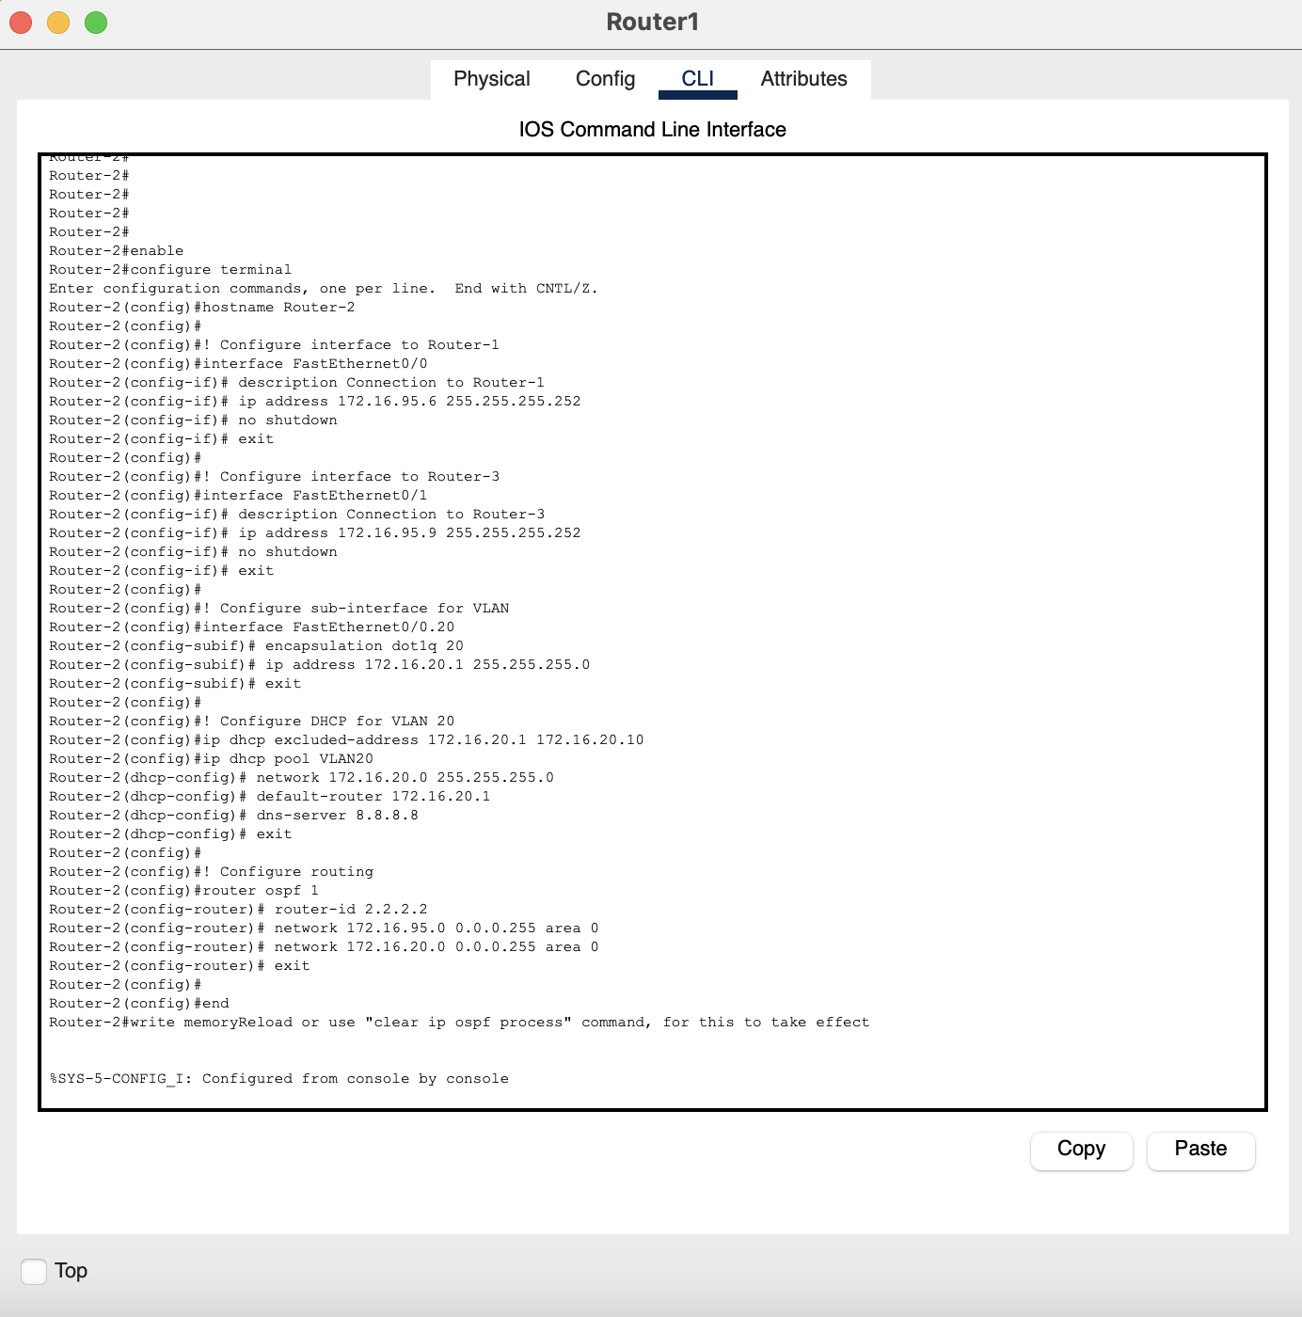

Figure 2 Configuration for Router 2 with DHCP and Encapsulation

1. Router 3

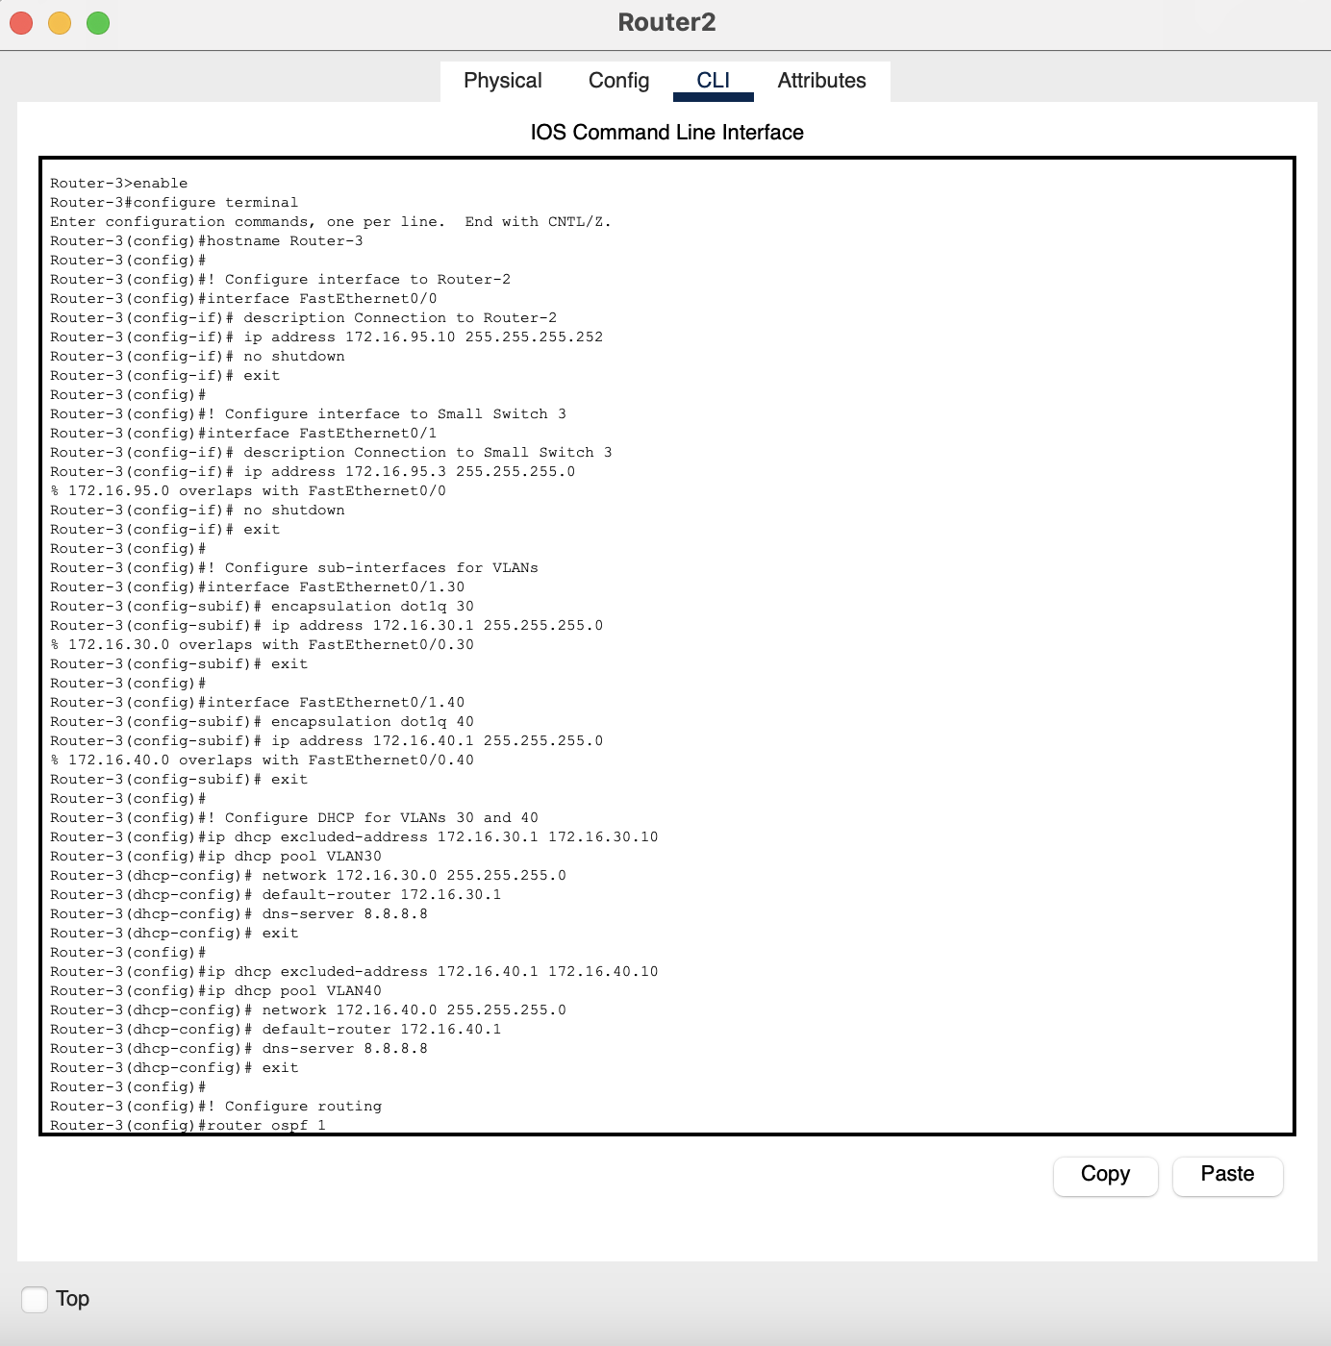

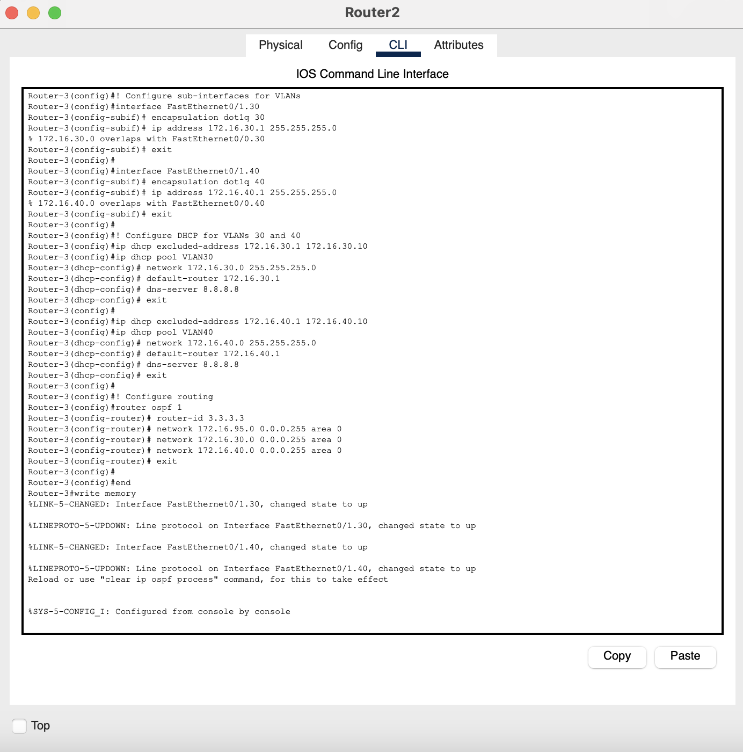

Figure 3 Configuration for Router 3 with DHCP and Encapsulation

### Configuration of Switch:

1. Trunk Switch 1(Small Switch): To connect between 2 different switch and Router

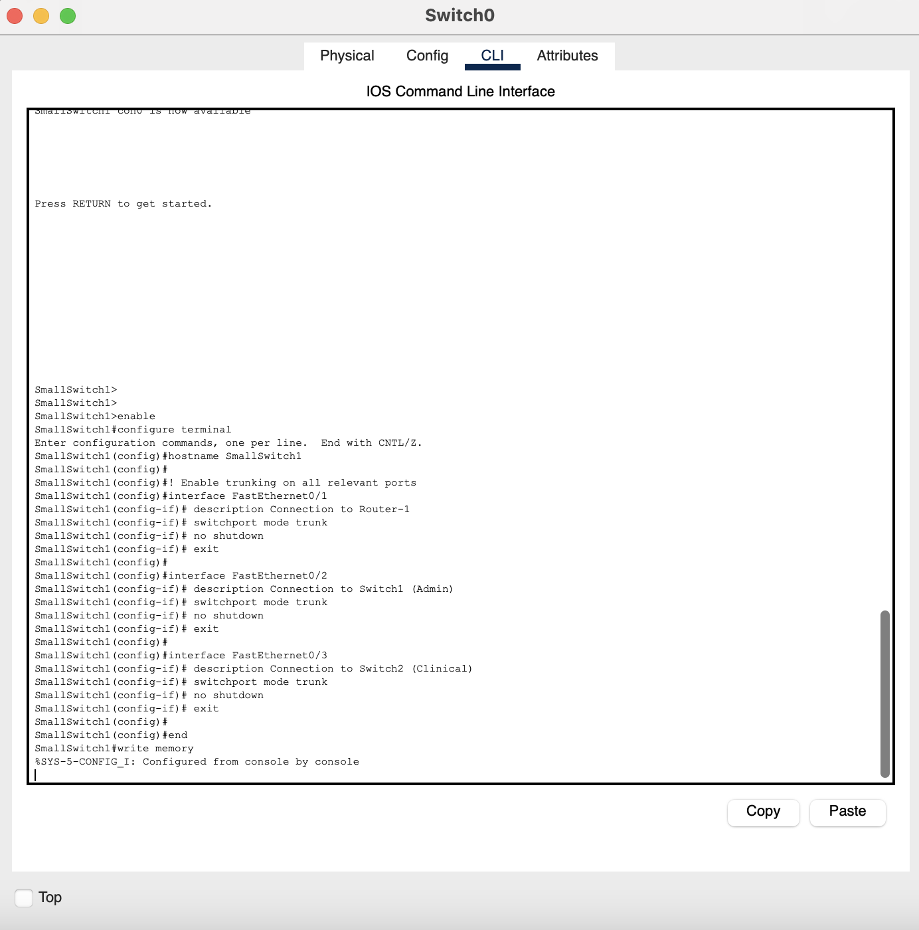

Figure 4 Configuration for Small switch 1 to trunk between Router and other switches

1. Trunk switch 2:

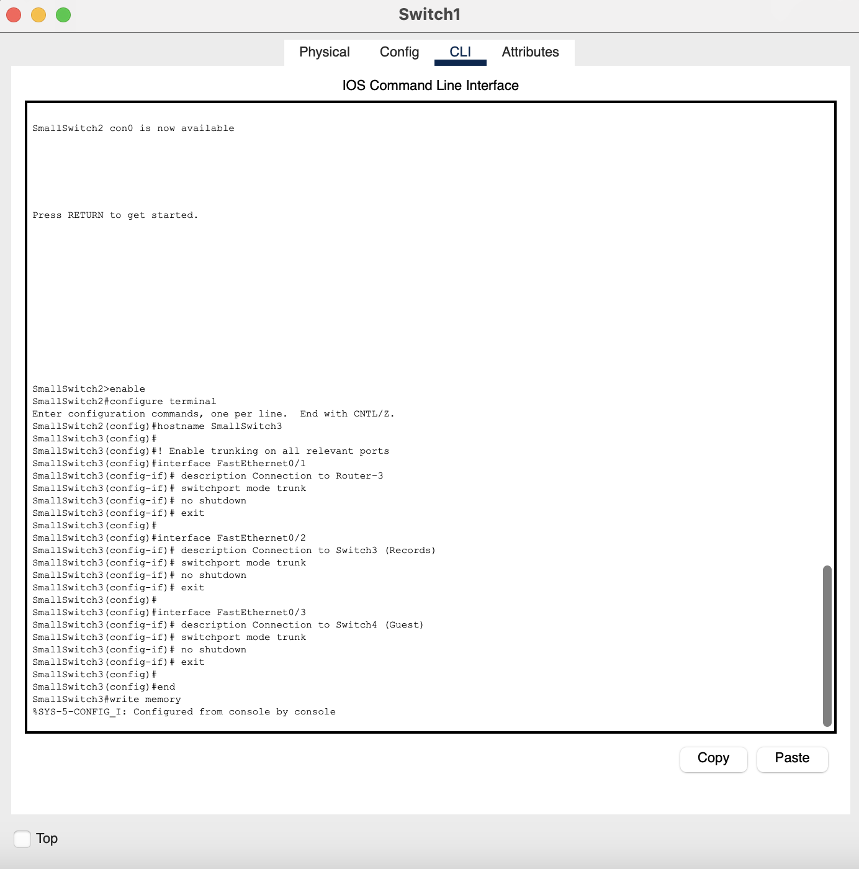

Figure 5 Configuration for Small switch 2 to trunk between Router and other switches

1. Main Switch 1[Admin]

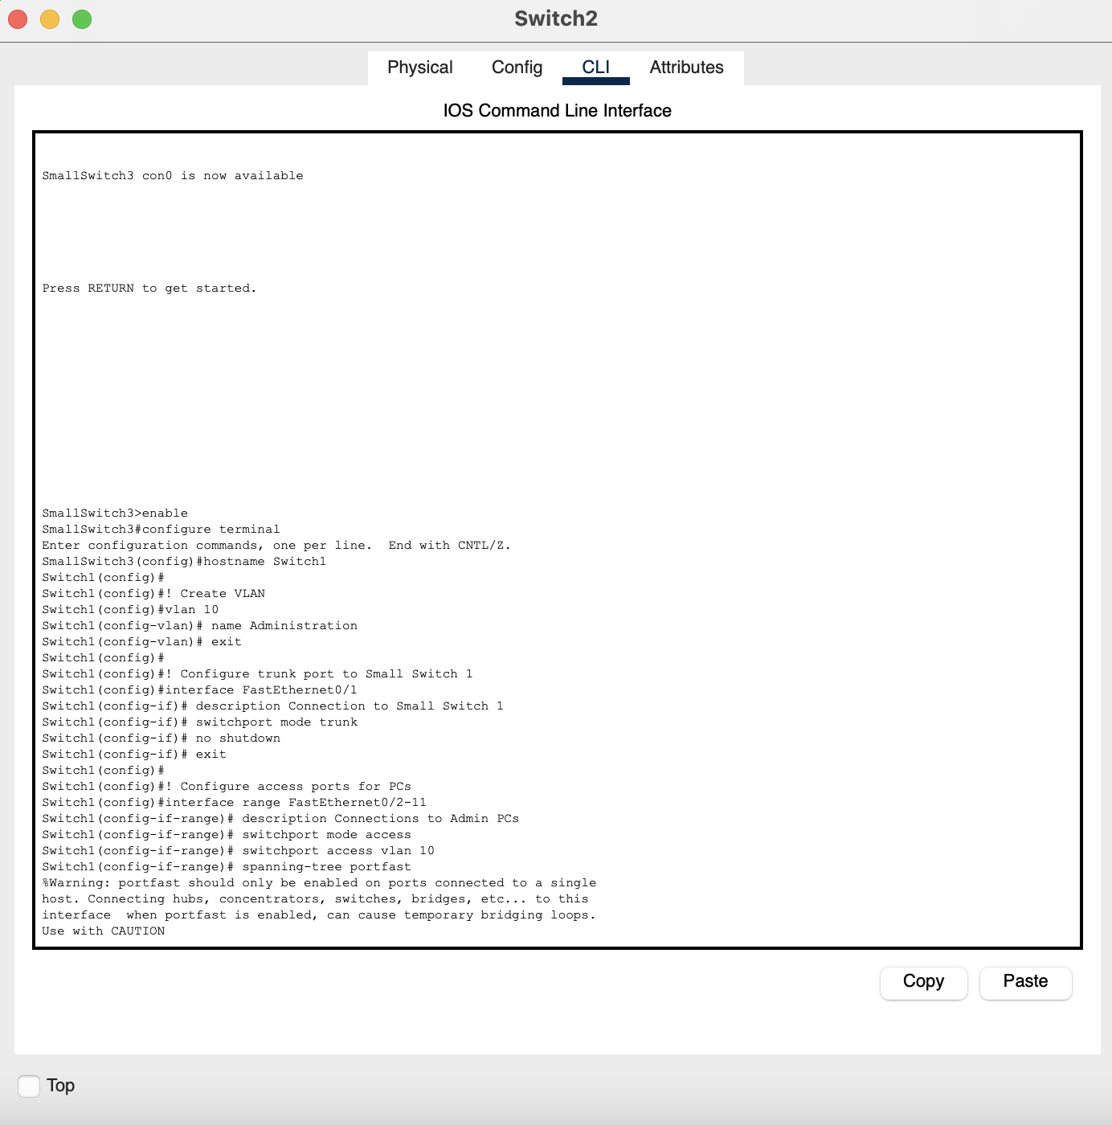

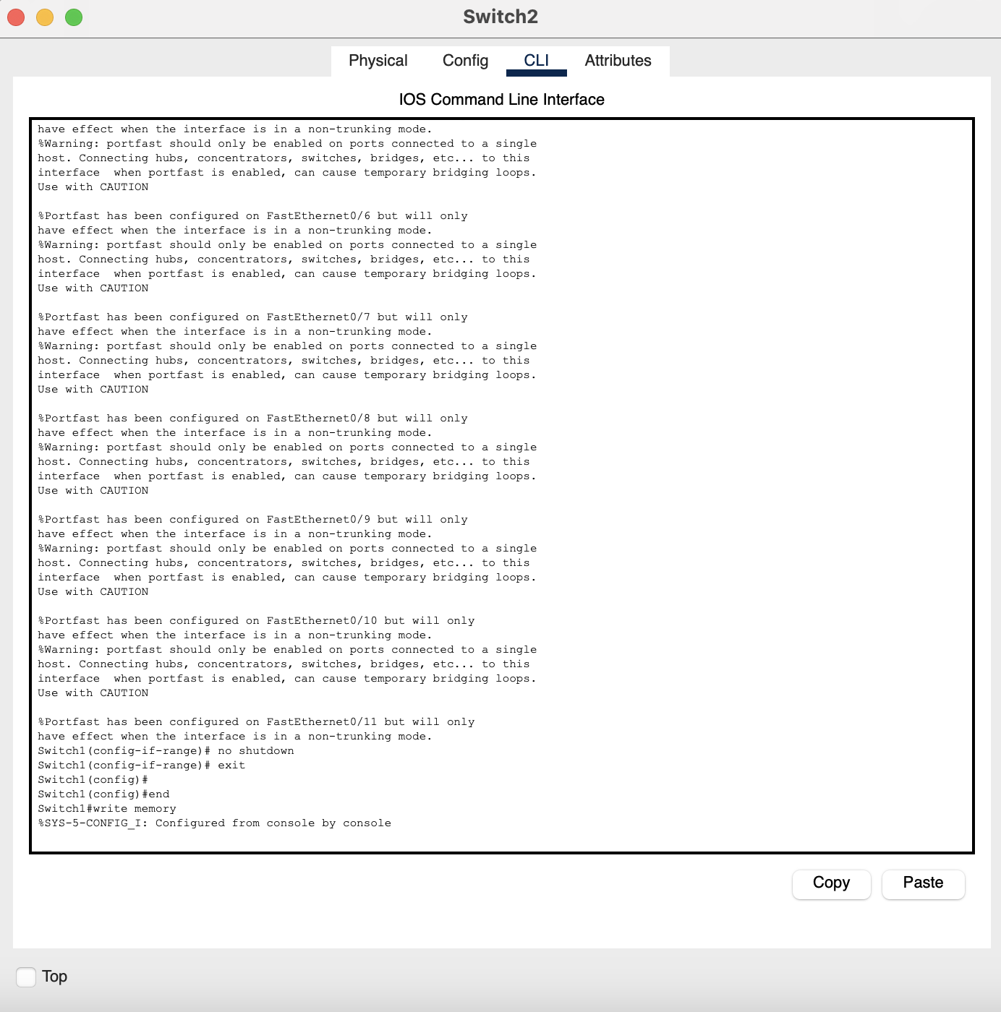

Figure 6 Configuration for main switch1 [Admin] between Trunk small switch 1 and PCs

1. Main Switch 2[Clinical]

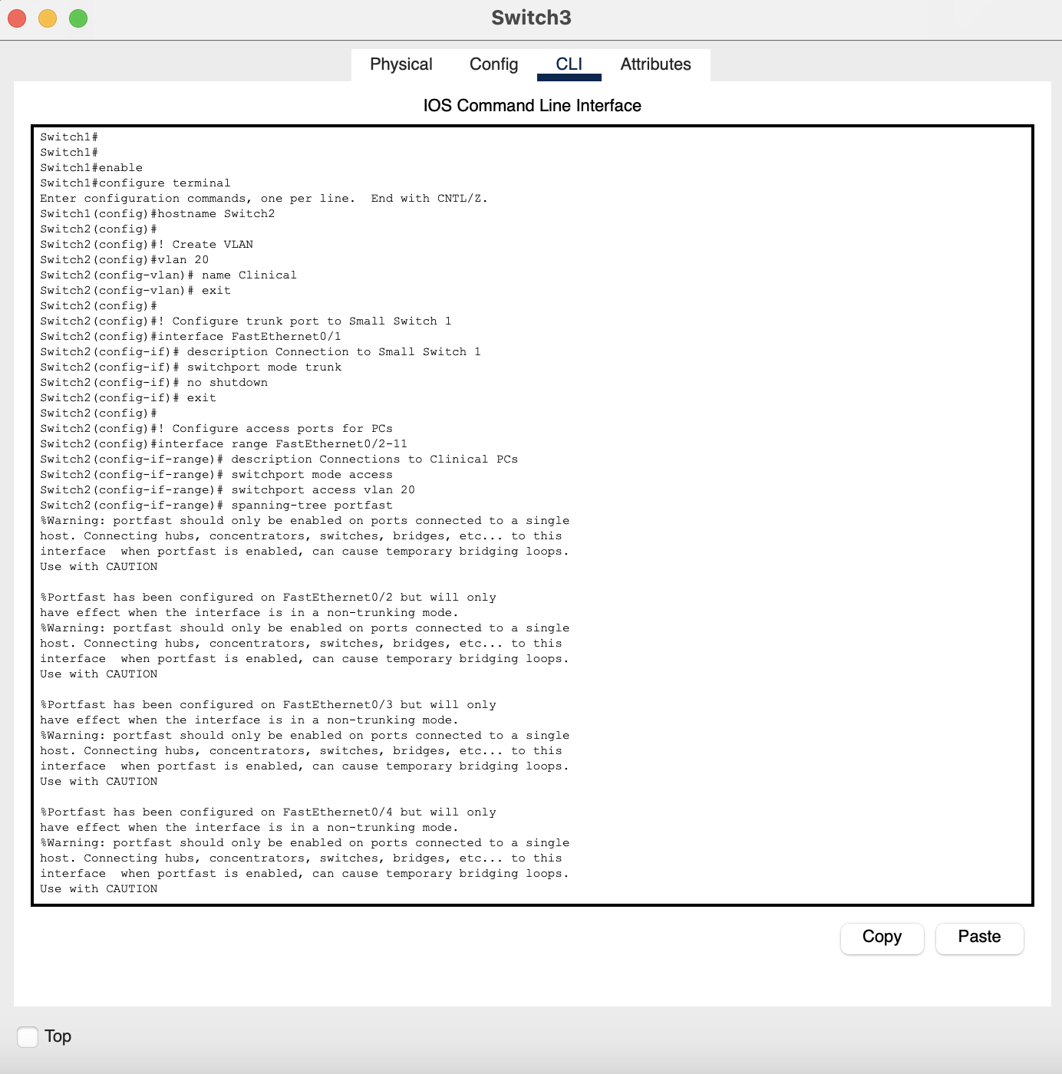

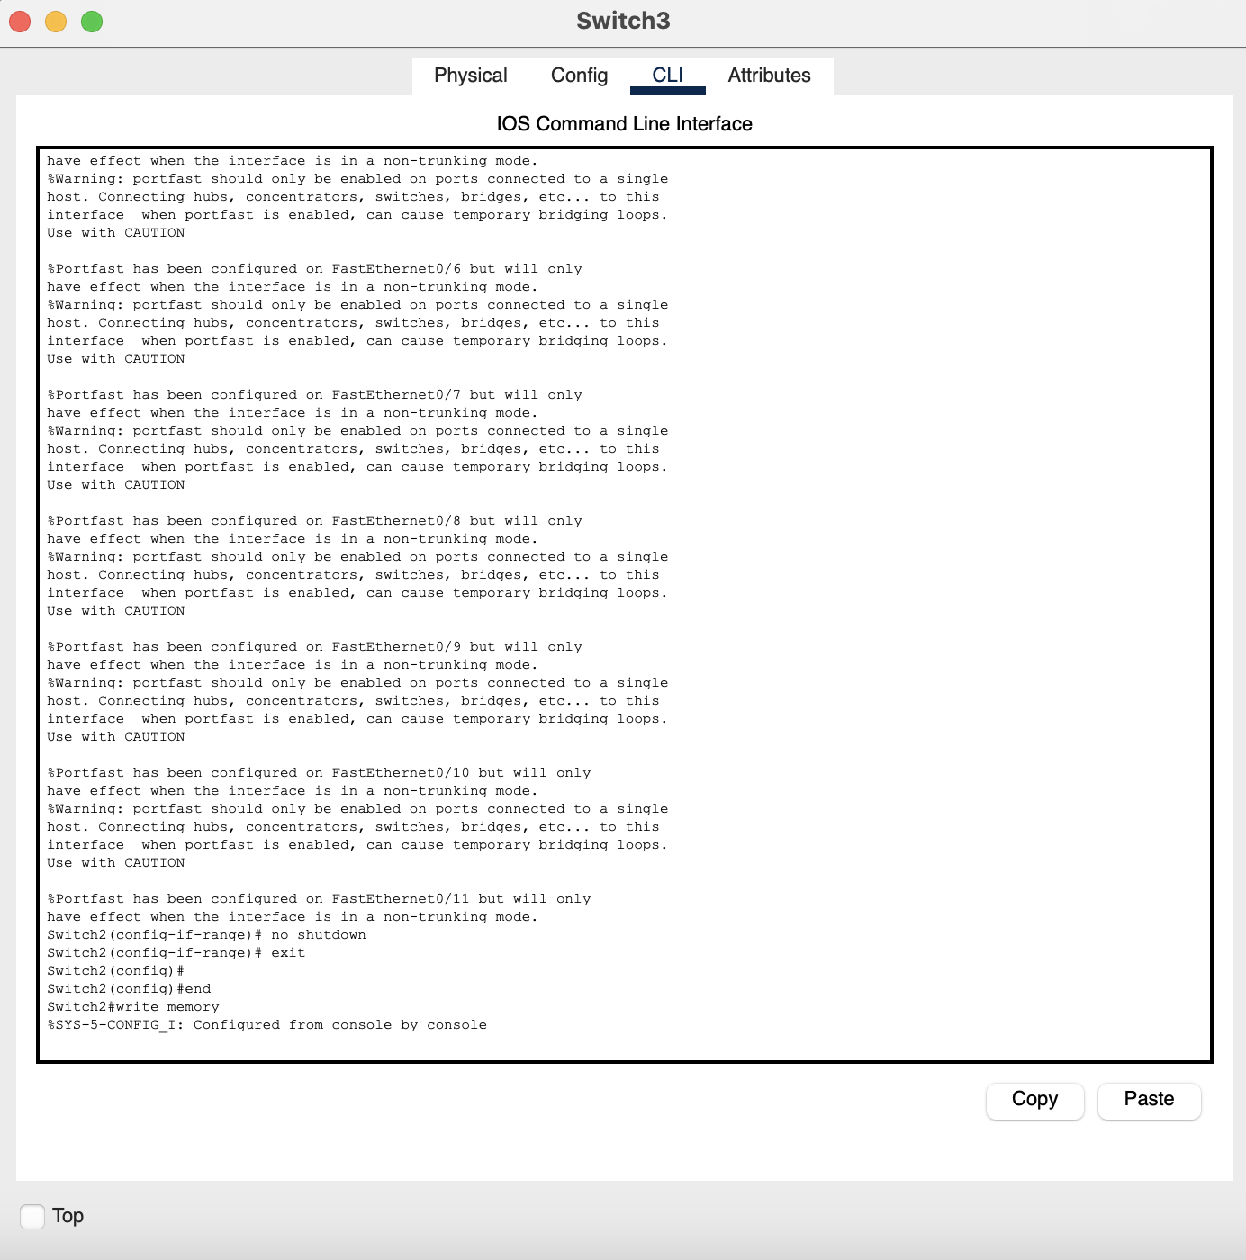

Figure 7 Configuration for main switch2 [Clinical] between Trunk small switch 1 and PCs

1. Main Switch 3[Records]

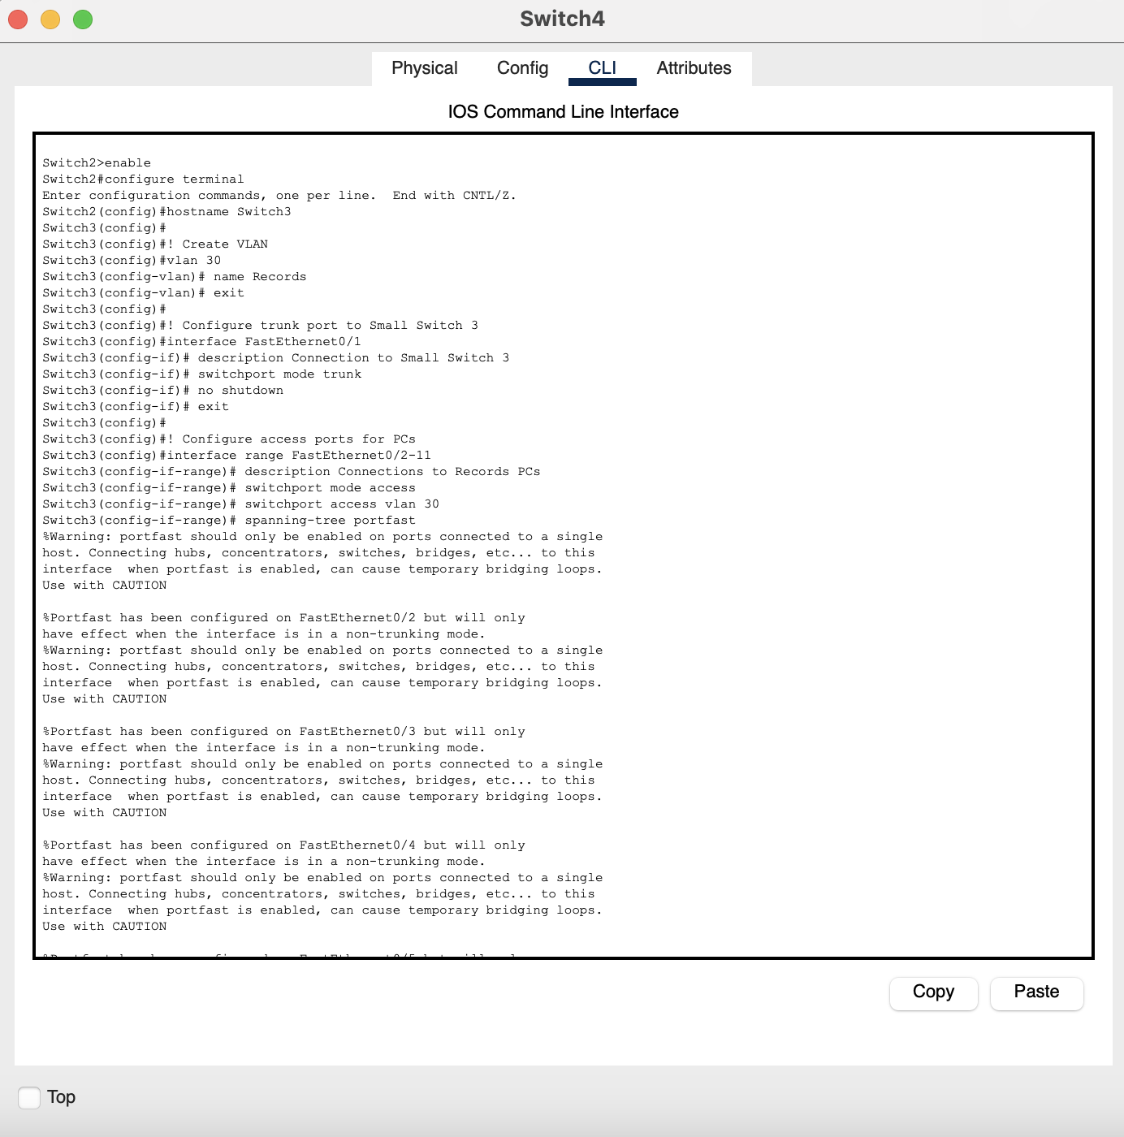

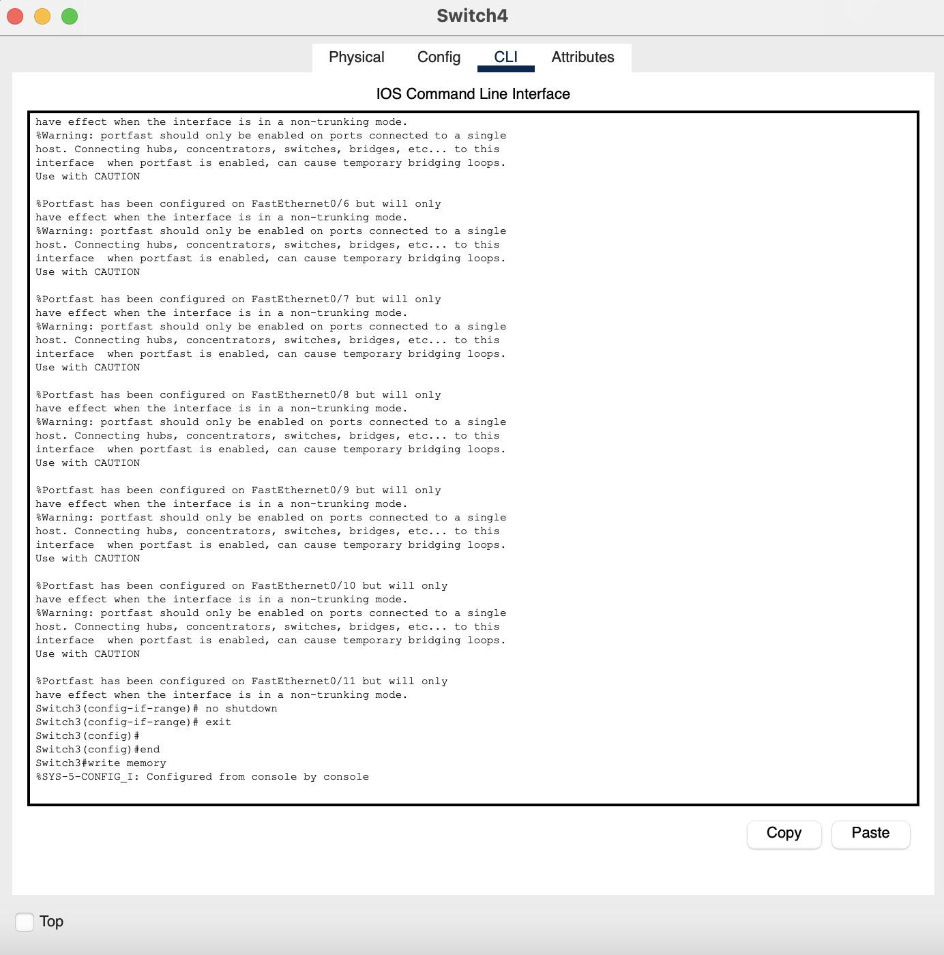

Figure 8 Configuration for main switch3 [Records] between Trunk small switch 2 and PCs

1. Main Switch 4[Guest]

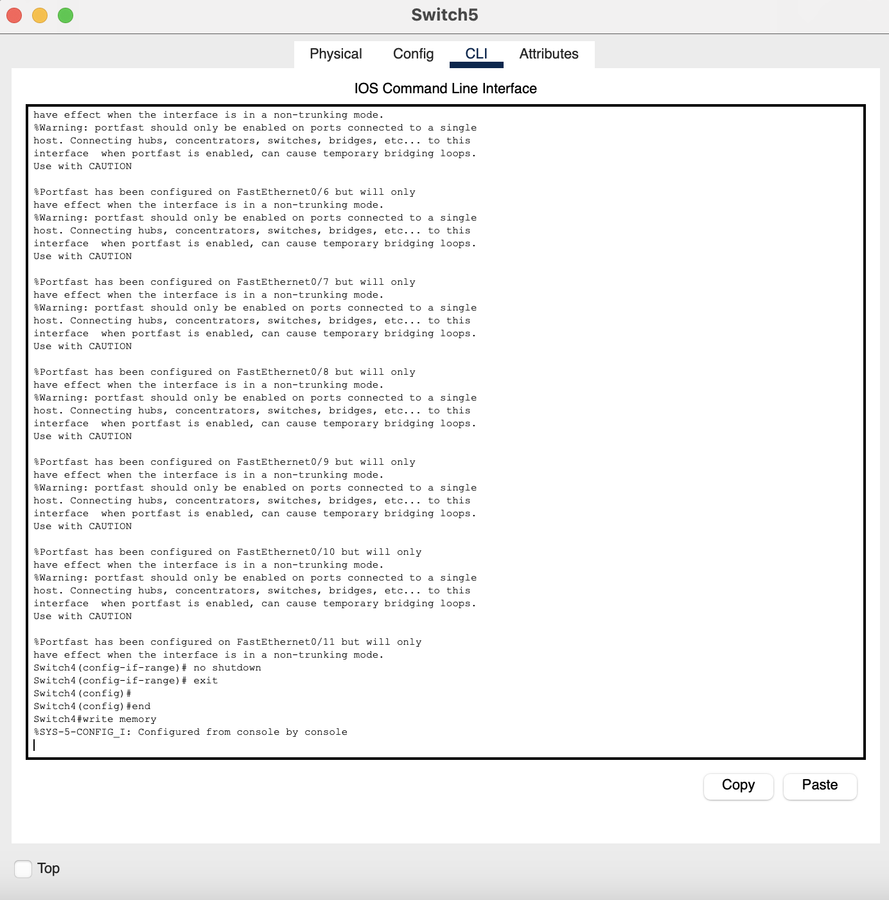

Figure 9 Configuration for main switch4 [Guest] between Trunk small switch 2 and PCs

## Routers Interface and IP route brief:

1. Router 1

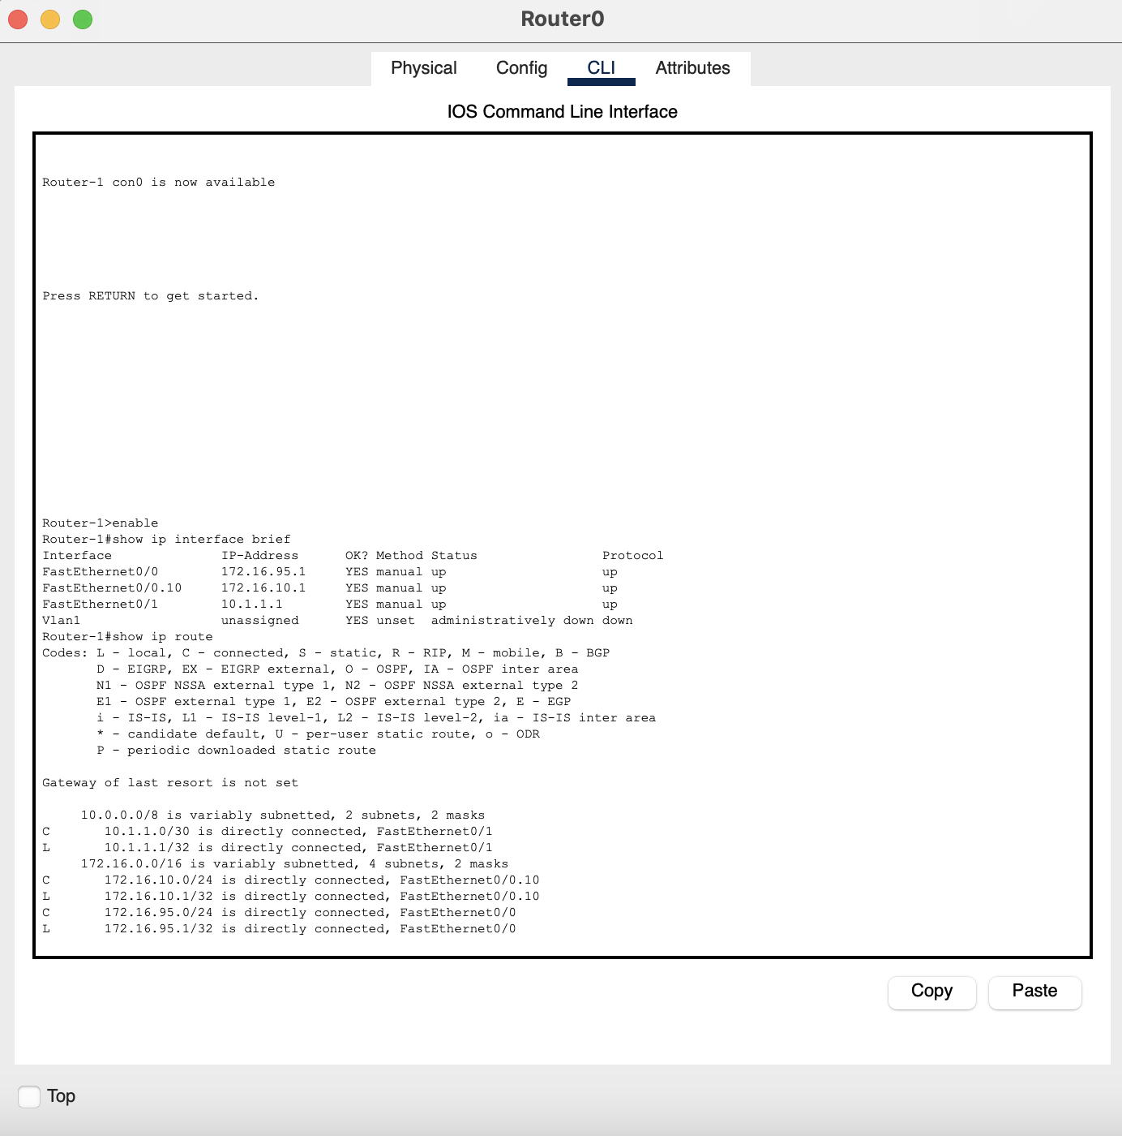

Figure 10 IP configure status and IP routing of Router 1

1. Router 2

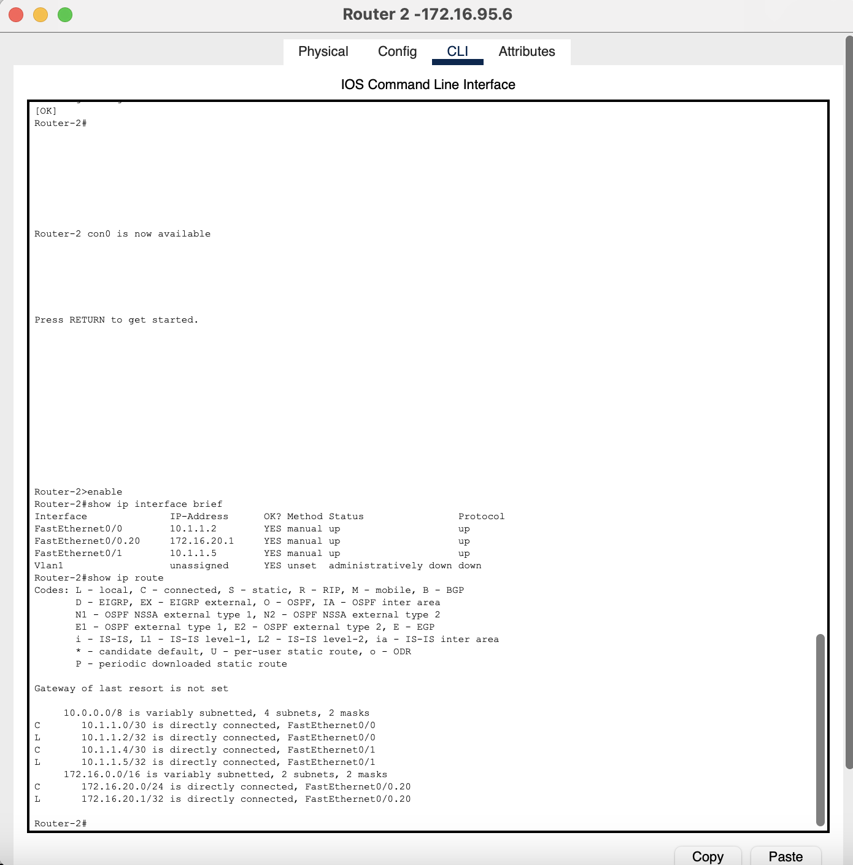

Figure 11 IP configure status and IP routing of Router 2

1. Router 3

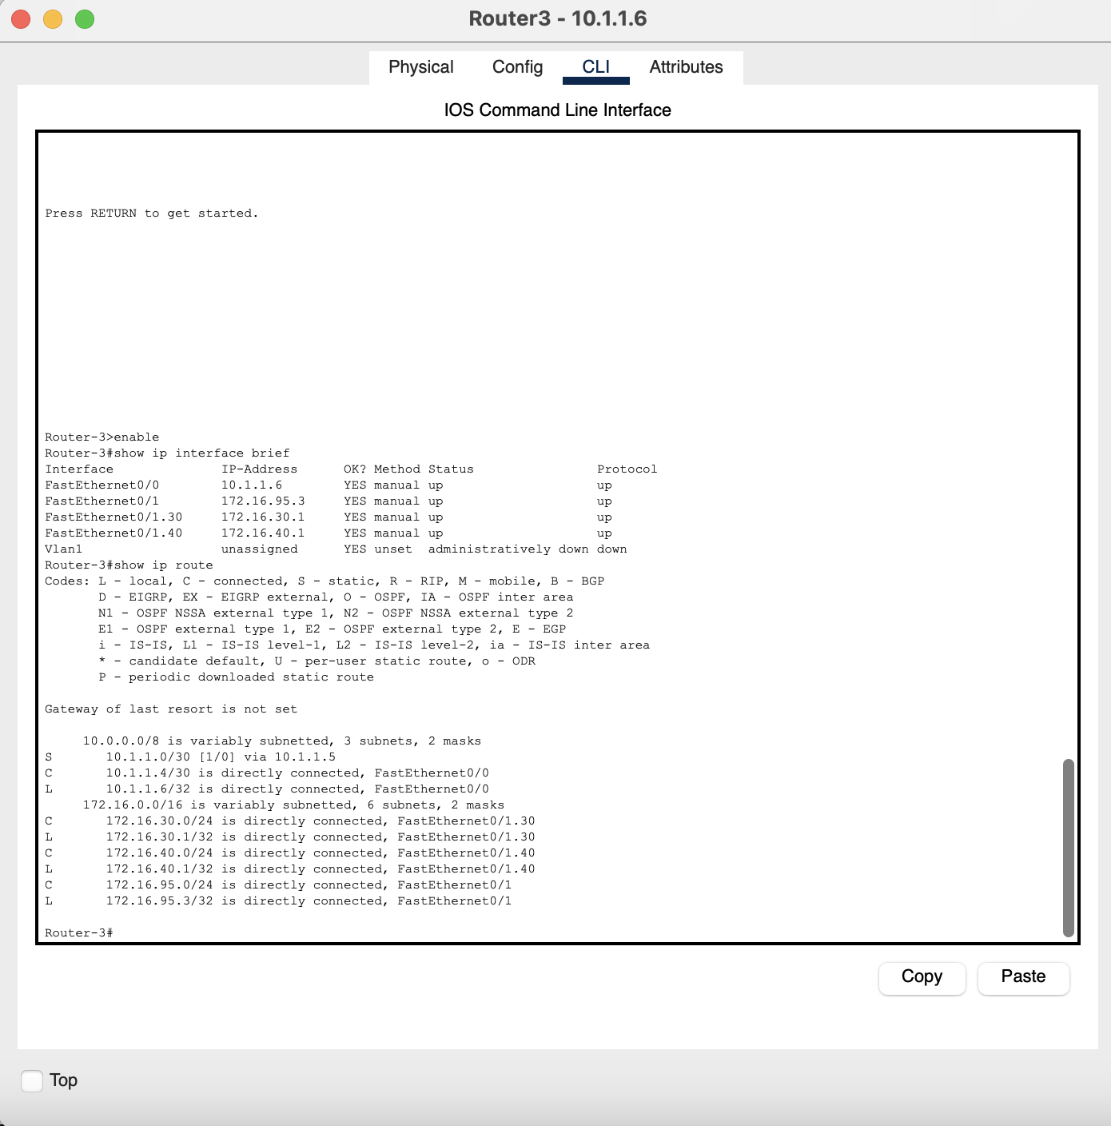

Figure 12 IP configure status and IP routing of Router 3

## Cisco Packet tracker Schematic Diagram:

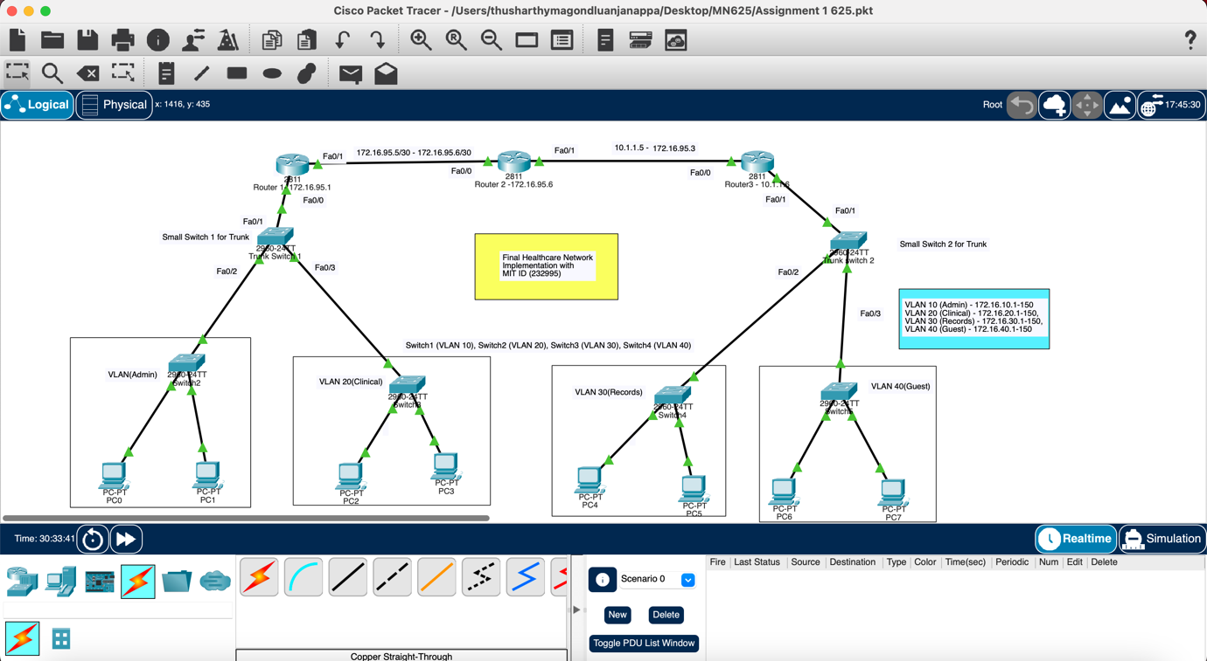

Figure 13 Implementation of Healthcare Network Architecture on Cisco Packet tracker

## IP Addressing Scheme:

I chose the private Class B network space 172.16.0.0/16 and included my MIT student ID (MIT232995) using numbers "**95**" within the third octet of my critical infrastructure [5].

IP Addressing Scheme (MIT ID: 232995)  
Table Shows various device used in the network Design and Configuration associated

|  |  |  |  |  |
| --- | --- | --- | --- | --- |
| **Devices in Scheme** | **Interface used** | **IP Address associated** | **Subnet Mask for IP** | **VLAN associated** |
| **Router-1** | Fa0/0 | 172.16.95.1 | 255.255.255.0 | - |
|  | Fa0/0.10 | 172.16.10.1 | 255.255.255.0 | 10 |
|  | Fa0/0.20 | 172.16.20.1 | 255.255.255.0 | 20 |
|  | Fa0/1 | 10.1.1.1 | 255.255.255.252 | - |
| **Router-2** | Fa0/0 | 10.1.1.2 | 255.255.255.252 | - |
|  | Fa0/1 | 10.1.1.5 | 255.255.255.252 | - |
| **Router-3** | Fa0/0 | 10.1.1.6 | 255.255.255.252 | - |
|  | Fa0/1 | 172.16.95.3 | 255.255.255.0 | - |
|  | Fa0/1.30 | 172.16.30.1 | 255.255.255.0 | 30 |
|  | Fa0/1.40 | 172.16.40.1 | 255.255.255.0 | 40 |
| **VLAN Networks** | VLAN 10 | 172.16.10.0/24 | 255.255.255.0 | 10 |
|  | VLAN 20 | 172.16.20.0/24 | 255.255.255.0 | 20 |
|  | VLAN 30 | 172.16.30.0/24 | 255.255.255.0 | 30 |
|  | VLAN 40 | 172.16.40.0/24 | 255.255.255.0 | 40 |

## DHCP Allocation Configuration Table

Table Show various DHCP Pool allocation on the VLAN and their IP range

|  |  |  |  |  |  |
| --- | --- | --- | --- | --- | --- |
| **VLAN Established** | **Router used for Configuration** | **DHCP Pool associated** | **IP Range available** | **Gateway** | **DNS Server** |
| 10 (Admin) | Router-1 | VLAN10 | 172.16.10.11-254 | 172.16.10.1 | 8.8.8.8 |
| 20 (Clinical) | Router-1 | VLAN20 | 172.16.20.11-254 | 172.16.20.1 | 8.8.8.8 |
| 30 (Records) | Router-3 | VLAN30 | 172.16.30.11-254 | 172.16.30.1 | 8.8.8.8 |
| 40 (Guest) | Router-3 | VLAN40 | 172.16.40.11-254 | 172.16.40.1 | 8.8.8.8 |

## VLAN Assignment Table

Table Shows Assigning VLAN to different department

|  |  |  |  |
| --- | --- | --- | --- |
| **VLAN ID** | **VLAN Name** | **Subnet** | **Purpose of each VLAN** |
| 10 | Administration | 172.16.10.0/24 | Administrative staff network for billing and Board communication |
| 20 | Clinical | 172.16.20.0/24 | Clinical staff network for instrument or medicine |
| 30 | Records | 172.16.30.0/24 | Patient records network to access data and provide data |
| 40 | Guest | 172.16.40.0/24 | Guest/visitor network for general purpose |

# Result: Ping Connectivity

1. **Ping between PCs of same VLAN9(admin)**

Figure 14 Ping connectivity between PCs with single VLAN

1. **Ping between PCs of Different VLAN**

Figure 15 Ping connectivity between PCs with Different VLAN

1. **Ping between Router 1 and PC of Admin system.**

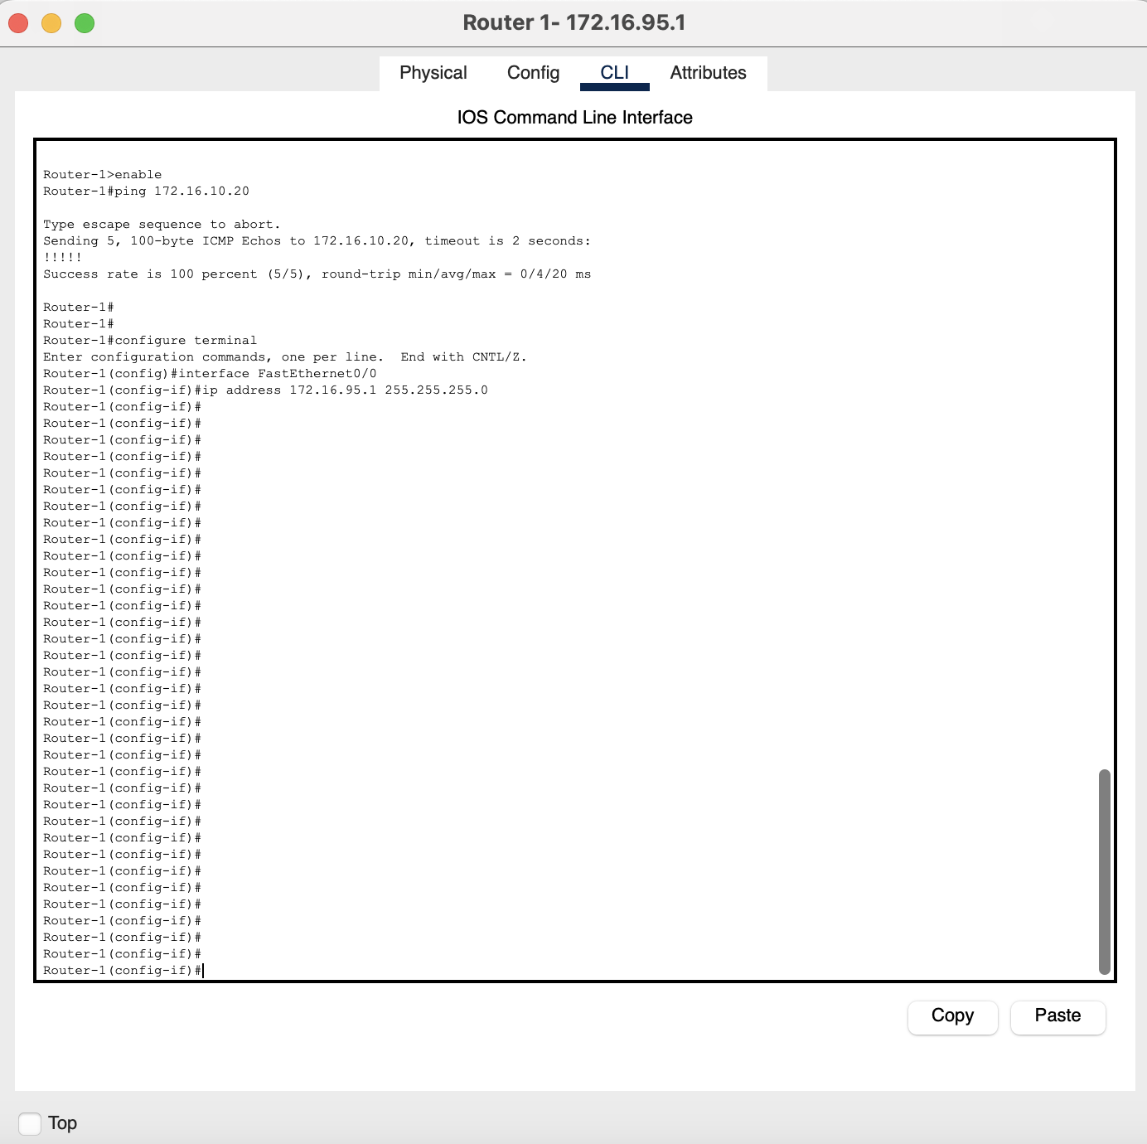

Figure 16 Ping connectivity between Router and PC of admin department

## DHCP allocation of IP address to PCs:

1. **Admin PCs**

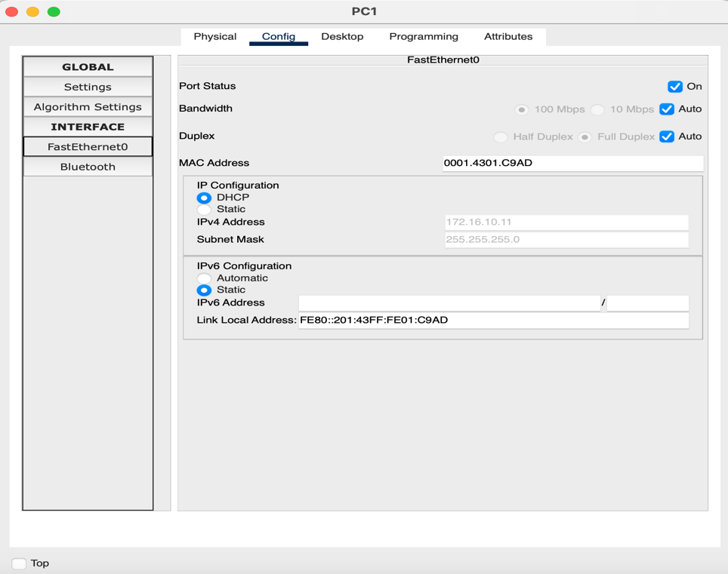

Figure 17 DHCP allocation of IP address on VLAN 10

1. Clinical PC:

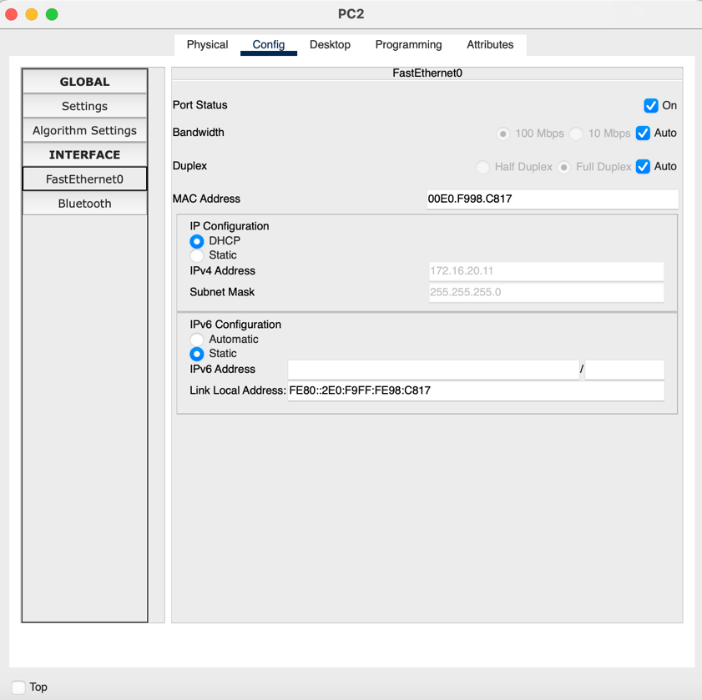

Figure 18 DHCP allocation of IP address on VLAN 20

1. **Record PC:**

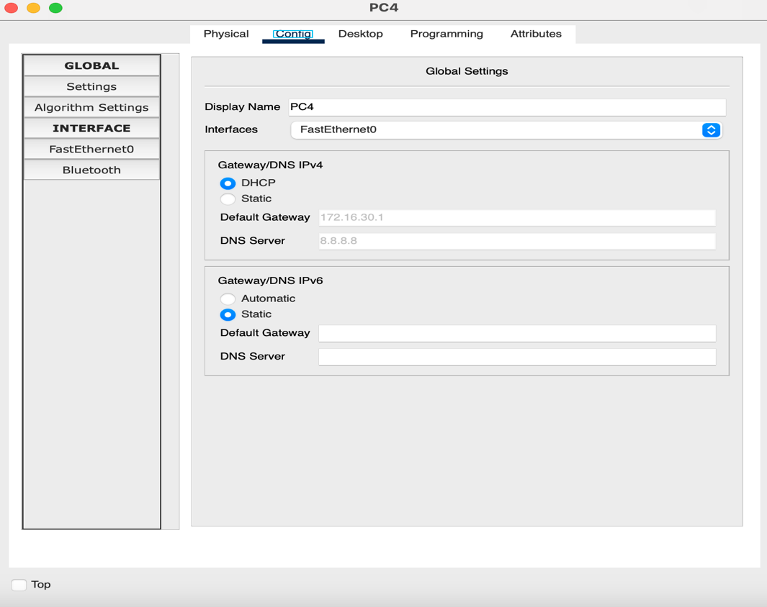

Figure 19 DHCP allocation of IP address on VLAN 30

1. **Guest PC:**

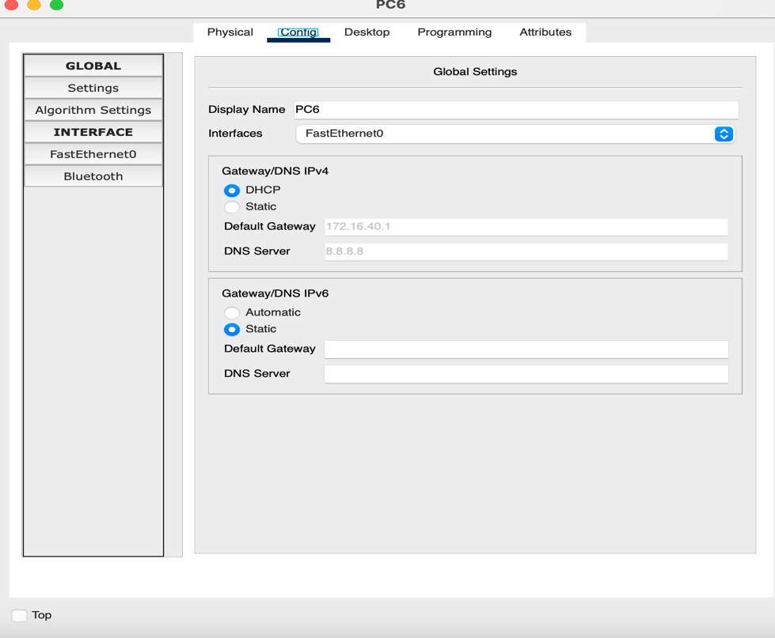

Figure 20 DHCP allocation of IP address on VLAN 40

# Summary:

This network architecture fulfills all security requirements and operational performance needs and future expansion prerequisites for Memorial Regional Healthcare. The hierarchical framework employs redundancy in its parts to ensure high service availability for essential healthcare needs while also benefiting from VLAN segmentation that secures crucial patient data [1] [2]. The organization can grow through its IP addressing system that maintains separate department boundaries [4].

Memorial Regional Healthcare will possess every capability needed to execute their EHR system needs and telehealth services development and healthcare data security compliance requirements through this design implementation [3].

# References:

[1] Mihaela Ulieru, “Design for Resilience of Networked Critical Infrastructures,” *IEEE Xplore*, Feb. 01, 2007. <https://ieeexplore.ieee.org/document/4233769>

(accessed Apr. 03, 2025).

[2] P. Karhunen, “Improving Information Security in Healthcare Networks With Software-Defined Networking,” *www.theseus.fi*, 2020. <https://www.theseus.fi/handle/10024/340055>

(accessed Apr. 02, 2025).

[3]J. Marron, “Implementing the Health Insurance Portability and Accountability Act (HIPAA) Security Rule”:, *uide to Network Security for Healthcare Organizations*, 2024, doi: <https://doi.org/10.6028/nist.sp.800-66r2>.

[4]Chintan Patadia, A. Patel, M. Gandhi, S. Patel, Namratha Jagadeesh, and Thanesh Nagarajan Thirupatthi, “Advanced DHCP Strategies for Seamless Inter-Campus Connectivity in Educational Networks,” *Advanced DHCP Strategies for Seamless Inter-Campus Connectivity in Educational Networks,* pp. 722–726, Oct. 2024, doi: <https://doi.org/10.1109/i-smac61858.2024.10714632>.

[5]Craig E. Kuziemsky, P. Andreev, Morad Benyoucef, T. O’Sullivan, and Syam Jamaly, “A Connectivity Framework for Social Information Systems Design in Healthcare,” *AMIA Annual Symposium Proceedings*, vol. 2016, p. 734, Feb. 2017, Accessed: Mar. 04, 2025. [Online]. Available: <https://pmc.ncbi.nlm.nih.gov/articles/PMC5333316/>

[6]S Chu and B. Cesnik, “A three-tier clinical information systems design model,” *International journal of medical informatics*, vol. 57, no. 2–3, pp. 91–107, 2000, doi: <https://doi.org/10.1016/s1386-5056(00)00057-5>.